DRONE DELIVERY NETWORK MANAGEMENT

22IT801-PROJECT-II A PROJECT REPORT
Submitted by

ADARSH AM (727722EUIT006) BHOOMIKA D (727722EUIT033) ARUNKUMAR M (727822EUIT501)

In partial fulfilment for the award of the

degree of

BACHELOR OF TECHNOLOGY

IN
INFORMATION TECHNOLOGY

SRI KRISHNA COLLEGE OF ENGINEERING AND TECHNOLOGY
An Autonomous Institution | Approved by AICTE | Affiliated to Anna University | Accredited by
NAAC with A++ Grade, Kuniamuthur, Coimbatore – 641008.

MARCH 2026

BONAFIDE CERTIFICATE
Certified that this project report “DRONE DELIVERY NETWORK MANAGEMENT” i s the bonafide work of ADARSH AM (727722EUIT006), BHOOMIKA D(727722EUIT033), ARUNKUMAR
M(727723EUIT501), who carried out the project under my supervision.

SIGNATURE SIGNATURE
Dr. T. RAJESH KUMAR Dr. M. ARUNACHALAM

HEAD OF THE DEPARTMENT SUPERVISOR
Professor Professor
Department of Information Department of Information
Technology Technology
Sri Krishna College of Sri Krishna College of
Engineering and Technology Engineering and Technology
Kuniamuthur Kuniamuthur
Coimbatore-641008 Coimbatore-641008

Submitted for the Project viva-voce examination held on

INTERNAL EXAMINER EXTERNAL EXAMINER

ACKNOWLEDGEMENT

We express our sincere thanks to the Management and Dr. K. Porkumaran, Principal, Sri Krishna College of Engineering and Technology, Coimbatore for providing us the facilities to carry out this project work.

We are thankful to Dr. T. Rajesh Kumar, Professor and Head, Department of Information Technology, for his continuous evaluation and comments given during the course of the project work.

We express our deep sense of gratitude to our supervisor Dr. M. Arunachalam, Professor, Department of Information Technology for his valuable advice, guidance, and support during the course of our project.

We would also l ike to thank our project coordinator Prof. M. Johnson M.E., Assistant Professor, Department of Information Technology for helping us in completing the project.

We express our heartfelt sense of gratitude and thanks to our beloved parents, family and friends who have helped during the project course.

ABSTRACT

The increasing demand for faster and more efficient delivery services has created challenges in traditional last-mile logistics, including traffic congestion and delayed deliveries. Drone-based delivery systems have emerged as a promising solution to improve delivery efficiency and reduce dependence on road transportation. This project presents a Drone Delivery Management and Simulation Platform designed to manage and monitor autonomous drone delivery operations.
The proposed system integrates a web-based dashboard, mobile monitoring application, backend server, and simulation engine to support real-time drone tracking, order management, battery-aware task assignment, No-Fly Zone avoidance, and weather-aware simulation. An interactive map interface enables visualization of drone movements, delivery routes, and infrastructure elements such as kiosks and restaurants. The platform also provides analytics to monitor delivery performance and fleet utilization.
The system demonstrates how intelligent drone fleet management can improve delivery efficiency and support sustainable urban logistics. The platform serves as a research and simulation environment for studying autonomous drone delivery systems.

TABLE OF CONTENT
CHAPTER TITLE PAGE No.

ACKNOWLEDGEMENT iv
ABSTRACT v
LIST OF FIGURES xi
LIST OF ABBREVIATIONS xii
- INTRODUCTION 1
  - Overview of the Project 1
  - Background 1
  - Objectives of the Project 2
  - Problem Statement 2
  - Scope of the Project 3
  - Key Features 3
  - Applications 4
  - Advantages 4
  - Limitations 4
- LITERATURE SURVEY 5
  - Introduction 5
  - Drone-Based Delivery Systems for Last-Mile 5
Logistics (2024)
  - Urban Drone Delivery Systems and 6
Technology Overview (2024)
  - Battery-Aware Task Assignment in Multi- 6
Drone Networks (2024)
  - Route Planning Strategies for Drone Delivery 6
Systems (2023)
  - Energy-Efficient Route Optimization for 7
Urban Drone Delivery (2024)
  - Digital Twin-Based Drone Delivery 7
Simulation (2025)
  - Real-Time Drone Fleet Monitoring Using 7
Web Dashboards (2025)
  - No-Fly Zone Aware Path Planning for UAV 8
Delivery (2024)
- SYSTEM REQUIREMENTS 9
  - Introduction 9
  - Hardware Requirements 9
  - Software Requirements 9
  - Functional Requirements 10
  - Non-Functional Requirements 11
  - Feasibility Study 11
    - Technical Feasibility 11
    - Economic Feasibility 12
    - Operational Feasibility 12
- EXISTING SYSTEM 13
  - Introduction 13
  - Traditional Delivery Systems 13
  - Existing Drone Delivery Platforms 13
  - Limitations of Existing Systems 14
  - Challenges in Current Approaches 14
  - Comparison with Proposed System 15
- PROPOSED SYSTEM 16
  - Introduction 16
  - Overall System Architecture 16
  - Module Description 18
    - Dashboard Module 18
    - Live Map Module 19
    - Orders Management Module 19
    - Drone Fleet Management Module 20
    - Kiosk Management Module 20
    - Restaurant Management Module 21
    - Analytics Dashboard Module 21
    - Alerts Center Module 22
  - Proposed System Flow 23
  - Drone State Management 24
  - Battery Drain Calculation Model 24
  - No-Fly Zone Avoidance Strategy 25
  - Real-Time Communication Design 26
  - Advantages of Proposed System 26
- IMPLEMENTATION 27
  - Introduction 27
  - Frontend Implementation 27
  - Backend Implementation 28
  - Simulation Engine 28
  - WebSocket Communication 28
  - Database Design 29
  - API Design 29
  - Security Considerations 30
- TESTING AND RESULTS 31
  - Introduction 31
  - Test Strategy 31
  - Test Case Description 31
  - Performance Evaluation 32
  - Result Analysis 32
  - Screenshots 33
- CONCLUSION AND FUTURE WORK 37
  - Conclusion 37
  - Achievements 37
  - Limitations 38
APPENDICES 40
Appendix I 40
Source Code 40
Appendix II 48
Screenshots 48
SDG MAPPING 53
REFERENCES 54

LIST OF FIGURES

FIGURE NO. | TITLE | PAGE NO.
5.1 | Overall System Architecture | 17
5.2 | Order Processing Flowchart | 23
5.3 | Drone State Diagram | 24
5.4 | Battery Calculation Flow | 25
5.5 | NFZ Avoidance Concept | 26
7.6.1 | Dashboard | 33
7.6.2 | Live Map | 34
7.6.3 | Orders | 34
7.6.4 | Drone Fleet Management | 35
7.6.5 | Kiosk Management | 35
7.6.6 | Analytics | 36
A2.1 | Login Page | 48
A2.2 | Dashboard | 49
A2.3 | Live Map | 49
A2.4 | Orders Page | 50
A2.5 | Drone Fleet Page | 51
A2.6 | Kiosk Management | 51
A2.7 | Analytics Dashboard | 52

LIST OF ABBREVIATIONS

ABBREVIATION | EXPANSION
API | Application Programming Interface
CORS | Cross-origin Resource sharing
CPU | Central Processing Unit
VS | Visual Studio
OS | Operating System
HTTP | Hyper Text Transfer Protocol
DGCA | Directorate General of Civil Aviation
DFD | Data Flow Diagram
DOM | Document Object Model
GPS | Global Positioning System
JSX | JavaScript XML
JSON | Javascript Object Notation
KPI | Key Performance Indicator
NFZ | No Fly Zone
NPM | Node Package Manager
RAM | Random Access Memory
REST | Representational State Transfer
TCP | Transmission Control Protocol
UAV | Unmanned Aerial Vehicle
UI | User Interface
UML | Unified Modelling Language
URL | Uniform Resource Locator
UUID | Universally Unique Identifier

CHAPTER 1 INTRODUCTION

Overview of the Project

The Drone Delivery Management and Simulation Platform is designed to model and manage autonomous drone-based food delivery operations. The system provides a complete digital environment where drones, orders, kiosks, restaurants, and delivery routes are simulated in real time. It enables administrators to monitor drone movements live, assign delivery tasks, manage charging infrastructure, and analyze fleet performance.
The platform combines a web-based dashboard and a mobile companion application with a backend simulation engine. Real-time updates are delivered using WebSocket communication, allowing multiple users to observe fleet activity simultaneously. The simulation operates on a fixed time tick, ensuring consistent drone movement, battery consumption, and weather impact calculations.
This project focuses on solving last-mile delivery challenges by demonstrating how autonomous drones can optimize delivery time, reduce human involvement, and improve operational efficiency while maintaining safety through intelligent routing and battery- aware decision making.

Background

With the rapid growth of online food ordering and e-commerce services, traditional delivery systems face increasing pressure due to traffic congestion, rising fuel costs, and delayed deliveries. Autonomous drones offer a promising alternative by enabling aerial transportation that bypasses road networks and reaches destinations faster.
However, deploying drone delivery at scale introduces complex challenges such as route planning, battery limitations, restricted airspaces, weather variability, collision prevention, and fleet coordination. Most existing systems either focus on isolated aspects

or are closed commercial platforms.

This project was developed to provide an integrated simulation-based solution that models these real-world constraints. It serves as a learning platform for students and developers to understand drone logistics, system architecture, and real-time fleet management.

Objectives of the Project

The primary objectives of this project are:

    - To design a real-time drone delivery simulation platform.
    - To implement intelligent drone assignment based on battery availability and distance.
    - To support No-Fly Zone avoidance during route computation.
    - To simulate realistic battery consumption influenced by payload, altitude, speed, and weather.
    - To provide live fleet visualization through web and mobile applications.
    - To track operational metrics such as delivery success rate, drone utilization, and charging efficiency.
    - To create a scalable backend architecture suitable for future enhancements.

Problem Statement

Traditional delivery systems depend heavily on ground transportation, leading to inefficiencies caused by traffic, labor constraints, and environmental impact. While drones present a viable alternative, managing autonomous drone fleets requires sophisticated software capable of handling routing, energy management, safety compliance, and real-time coordination.
There is a lack of open and comprehensive platforms that integrate these aspects into a single system. This project addresses this gap by developing a unified drone delivery simulation and management platform that incorporates routing intelligence, battery

modeling, weather effects, and operational analytics.

Scope of the Project

The scope of this project includes:

    - Simulation of autonomous drone operations.
    - Real-time visualization of drone movements.
    - Intelligent order assignment based on battery capacity.
    - No-Fly Zone detection and avoidance.
    - Weather-based speed and energy consumption modeling.
    - Web-based administrative dashboard.
    - Mobile application for monitoring drone activity.
    - Analytics for fleet performance.

The project does not include physical drone hardware integration or customer-facing ordering systems. These areas are considered future enhancements.

Key Features

    - Real-time drone tracking using WebSocket updates.
    - Battery-aware pre-flight validation.
    - Dynamic route planning with No-Fly Zone avoidance.
    - Weather simulation affecting drone behavior.
    - Charging kiosk management.
    - Multi-user synchronized views.
    - Fleet analytics dashboard.
    - Modular backend architecture.

Applications

The system can be applied in:

    - Research and academic environments.
    - Smart city logistics planning.
    - Drone delivery feasibility studies.
    - Training simulations for drone operations.
    - Prototype development for autonomous delivery startups.

Advantages

    - Faster delivery compared to ground transportation.
    - Reduced manpower requirements.
    - Lower environmental impact.
    - Scalable architecture.
    - Realistic operational modeling.
    - Improved delivery success through intelligent battery management.

Limitations

    - Uses in-memory storage instead of persistent databases.
    - Simulation-based environment only.
    - Limited geographic coverage.
    - Simplified physics compared to real drone flight controllers.

CHAPTER 2 LITERATURE SURVEY

Introduction

The rapid advancement of unmanned aerial vehicle (UAV) technology has significantly transformed the field of logistics and last-mile delivery. Drone-based delivery systems are increasingly being explored as an efficient alternative to traditional ground transportation. These systems promise faster delivery times, reduced operational costs, and improved accessibility to remote areas. However, implementing reliable drone delivery networks requires addressing several challenges such as route optimization, battery management, restricted airspace handling, weather adaptation, and real-time fleet monitoring.
Several research studies have focused on developing algorithms, simulation frameworks, and intelligent monitoring systems to improve drone delivery operations. While many existing solutions address specific components such as navigation, battery optimization, or geofencing, few systems provide a comprehensive framework that integrates all operational aspects within a unified platform. The following survey reviews recent research contributions related to drone delivery systems and identifies the limitations that motivate the development of the proposed Drone Delivery Management and Simulation Platform.

Drone-Based Delivery Systems for Last-Mile Logistics (2024)

Chen, Wang, and Zhang proposed a simulation framework for managing autonomous drone fleets used in last-mile delivery operations [1]. The study focuses on simulating drone fleet coordination and evaluating delivery performance under different operational scenarios. The framework demonstrates how simulation tools can improve delivery efficiency and resource allocation. However, the proposed system primarily emphasizes fleet simulation and management rather than real-time operational monitoring. Features such as advanced battery-aware decision making and integrated analytics dashboards are not extensively addressed.

Urban Drone Delivery Systems and Technology Overview (2024)

Garcia, Rossi, and Chen conducted a comprehensive review of urban drone delivery technologies, regulations, and applications [2]. Their study highlights the growing interest in drone-based logistics and discusses challenges related to airspace regulation, infrastructure development, and operational safety. While the research provides a broad overview of drone delivery ecosystems, it focuses mainly on theoretical analysis and regulatory aspects. Practical implementation frameworks that combine simulation, monitoring, and operational control are not extensively explored.

Battery-Aware Task Assignment in Multi-Drone Networks (2024)

Johnson, Miller, and Brown proposed a battery-aware task assignment strategy for multi- drone delivery systems [3]. Their research focuses on optimizing task allocation based on drone battery levels to reduce mission failures caused by insufficient energy. The system improves delivery reliability by assigning tasks only to drones with sufficient battery capacity. However, the study mainly focuses on energy-based task allocation and does not incorporate other operational factors such as weather influence, restricted airspaces, or real-time monitoring dashboards.

Route Planning Strategies for Drone Delivery Systems (2023)

Kumar, Singh, and Sharma presented a survey on route planning techniques for drone- based delivery systems [4]. The study reviews commonly used path planning algorithms such as A*, Dijkstra, and heuristic-based optimization methods. These techniques help drones identify efficient paths between source and destination points while minimizing travel distance. Although the research provides a strong foundation for drone navigation algorithms, it primarily focuses on routing strategies and does not address integrated fleet management, battery monitoring, or real-time visualization capabilities.

Energy-Efficient Route Optimization for Urban Drone Delivery (2024)

Lee and Park proposed an energy-efficient route planning algorithm for urban drone delivery networks [5]. Their work emphasizes reducing energy consumption by optimizing flight routes and minimizing unnecessary detours. The proposed approach improves delivery efficiency in dense urban environments. However, the study does not consider dynamic environmental factors such as weather variations or restricted airspace zones, which are important for real-world drone operations.

Digital Twin-Based Drone Delivery Simulation (2025)

Liu, Zhou, and Li introduced a digital twin-based simulation model for drone delivery networks [6]. The system creates a virtual representation of real-world drone operations to analyze system behavior under different scenarios. Digital twin technology enables predictive analysis and performance optimization. Despite these advantages, the proposed system mainly focuses on simulation modeling and lacks integrated operational dashboards, order management systems, and real-time monitoring mechanisms.

Real-Time Drone Fleet Monitoring Using Web Dashboards (2025)

Nguyen and Kim developed a web-based platform for monitoring drone fleets in real time [7]. The system provides live visualization of drone positions and operational metrics through a dashboard interface. While the platform successfully demonstrates real- time monitoring capabilities, it primarily focuses on visualization and does not include advanced simulation features such as weather impact modeling, intelligent route planning, or battery-aware decision making.

No-Fly Zone Aware Path Planning for UAV Delivery (2024)
Patel and Verma proposed a geofencing-based path planning method that prevents drones from entering restricted airspaces [8]. The system uses polygon-based No-Fly Zones to ensure safe navigation around sensitive locations such as airports and government facilities. Although the approach improves operational safety, it does not integrate

energy-aware routing or real-time fleet management, limiting its applicability in large- scale delivery networks.

CHAPTER 3
SYSTEM REQUIREMENTS

Introduction

This chapter describes the hardware, software, and functional requirements needed to implement the Drone Delivery Management and Simulation Platform. Proper requirement analysis ensures that the system meets operational goals such as real-time monitoring, intelligent drone assignment, and safe delivery execution.

Hardware Requirements

The system is primarily software based and can run on standard computing devices. No specialized drone hardware is required since the platform operates in a simulated environment.

Minimum Hardware Configuration

- Processor: Intel i5 or equivalent
- RAM: 8 GB
- Storage: 20 GB free disk space
- Display: 1366 × 768 resolution or higher
- Internet Connection: Required for WebSocket communication

Recommended Hardware Configuration

- Processor: Intel i7 or equivalent
- RAM: 16 GB
- Storage: SSD with 50 GB free space
- Display: Full HD

Software Requirements Frontend
- React with TypeScript
- React Native (mobile companion app)
- HTML, CSS, JavaScript
- Map rendering libraries

Backend

- Node.js
- TypeScript
- WebSocket server

Development Tools

- Visual Studio Code
- GitHub
- Postman

Operating System

- Windows / macOS / Linux

Functional Requirements

The system must provide the following functionalities:

- User authentication and role-based access
- Real-time drone tracking
- Order creation and assignment
- Battery-aware pre-flight validation
- Dynamic route planning
- No-Fly Zone detection and avoidance

- Weather simulation
- Charging kiosk management
- Analytics dashboard

Non-Functional Requirements Performance
- Real-time updates within 100 ms simulation ticks
- Smooth UI rendering

Scalability

- Support for multiple drones and users

Reliability

- Continuous simulation without crashes
- Automatic recovery from invalid states

Security

- Secure API communication
- Role-based access control

Usability

- Simple dashboard navigation
- Clear visual indicators

Feasibility Study

Technical Feasibility

The project uses widely adopted technologies such as React, Node.js, and WebSockets. Simulation logic is handled through TypeScript, making development technically

feasible.

Economic Feasibility

The system uses open-source tools and does not require physical drone hardware. Development and operational costs remain low.

Operational Feasibility

The platform provides user-friendly interfaces and requires minimal training for operators.

CHAPTER 4 EXISTING SYSTEM

Introduction

This chapter analyzes traditional delivery mechanisms and existing drone-based platforms. It identifies limitations in current approaches and highlights challenges that motivate the need for the proposed Drone Delivery Management and Simulation Platform.

Traditional Delivery Systems

Conventional delivery systems depend mainly on ground transportation such as bikes, cars, and vans. These methods suffer from traffic congestion, limited manpower availability, fuel costs, and inconsistent delivery times.
Manual route planning and human dependency increase operational overhead and reduce scalability. Environmental impact is also higher due to fossil fuel consumption. Although GPS tracking is available in some systems, real-time optimization and automation are minimal.

Existing Drone Delivery Platforms

Several organizations have experimented with drone-based deliveries. Most existing platforms focus on direct point-to-point transportation using predefined routes. While these systems demonstrate feasibility, they lack comprehensive fleet management capabilities.
Current drone platforms usually provide:

    - Basic navigation

    - Live location tracking

    - Payload delivery

However, advanced features such as dynamic rerouting, battery-aware order assignment, No-Fly Zone avoidance, and analytics are either limited or absent.
Additionally, many solutions are proprietary and do not allow customization or academic experimentation.

Limitations of Existing Systems

The major drawbacks of current systems include:

    - Absence of intelligent battery validation before flight
    - Lack of integrated No-Fly Zone handling
    - Minimal weather-aware operation
    - Limited multi-drone coordination
    - No centralized analytics dashboard
    - Restricted scalability
    - High dependency on manual intervention

These limitations reduce reliability and prevent realistic operational modeling.

Challenges in Current Approaches

Existing drone delivery approaches face several technical and operational challenges:

    - Accurate estimation of battery consumption
    - Safe navigation in restricted airspaces
    - Handling unexpected weather conditions
    - Coordinating multiple drones simultaneously

    - Maintaining real-time communication

    - Ensuring delivery reliability

Without addressing these challenges, large-scale drone delivery deployment remains impractical.

Comparison with Proposed System

The proposed system improves upon existing approaches by introducing:

    - Battery-aware drone assignment
    - Dynamic No-Fly Zone avoidance
    - Weather-influenced simulation
    - Real-time multi-user monitoring
    - Charging kiosk management
    - Fleet analytics and performance tracking
    - Modular and extensible architecture

Unlike existing systems, the proposed platform provides a unified environment combining simulation, management, and visualization.

CHAPTER 5 PROPOSED SYSTEM

Introduction

The proposed Drone Delivery Management and Simulation Platform is a real-time, full- stack system designed to simulate and manage autonomous drone-based food delivery operations. The system integrates intelligent routing, battery-aware decision making, weather modeling, and live fleet monitoring within a unified architecture.
Unlike traditional delivery or basic drone prototypes, this platform combines simulation logic with administrative tools, analytics, and multi-user visualization.

Overall System Architecture

The system follows a three-layer architecture:

- Presentation Layer
- Application Layer
- Simulation and Data Layer
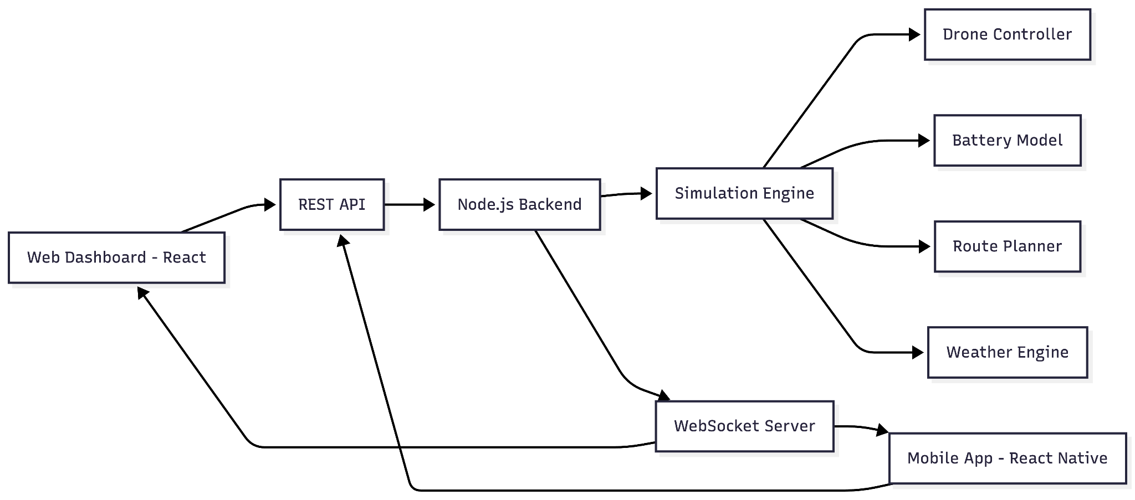

Figure 5.1 – Overall System Architecture

Architecture Explanation

- Web and Mobile applications interact with backend through REST APIs.

- WebSocket server provides real-time updates.

- Simulation engine runs at fixed intervals.

- Route planner checks No-Fly Zones.

- Battery model calculates energy consumption.

- Weather engine modifies drone performance.

Module Description

The proposed system is divided into multiple functional modules, each responsible for a specific aspect of drone delivery operations. These modules collectively ensure real-time monitoring, intelligent decision making, and efficient fleet coordination.

Dashboard Module

The Dashboard acts as the central control panel for administrators and operators. It provides a high-level overview of the entire system and allows users to manage simulation scenarios.
Key functionalities include:

      - Live KPI cards displaying total drones, active drones, pending orders, delivery

success rate, average fleet battery level, and total revenue.

      - Simulation controls such as Start, Pause, Resume, and Speed Multiplier to manage the simulation runtime.

      - Scenario selector supporting Normal, Peak Hour, and Bad Weather operational modes.

      - Weather impact slider ranging from 0% to 100% to dynamically influence drone performance.

      - Recent alerts panel showing the latest system notifications and warnings.

This module enables quick decision making by presenting real-time operational insights.

Live Map Module

The Live Map module provides geographical visualization of all system entities using an interactive MapLibre GL map of the Delhi NCR region with optional 3D tilt.
Features include:

      - Real-time drone position tracking with updates every 100 milliseconds.

      - Layer toggles for Drones, Kiosks, Restaurants, No-Fly Zones, and Routes.

      - Interactive marker popups displaying detailed information for drones, kiosks, and restaurants.
This module allows operators to visually monitor fleet movement and infrastructure

status.

Orders Management Module

This module handles the complete lifecycle of delivery orders. Functions include:
      - Viewing active, pending, completed, and failed orders.

      - Creating new delivery orders by selecting restaurant and delivery location.

      - Tracking order status through pickup, transit, delivery, and return phases.

      - Priority assignment with Low, Normal, High, and Urgent levels.

The module ensures systematic order processing and efficient drone allocation.

Drone Fleet Management Module

The Drone Fleet Management module provides detailed control and monitoring of all drones.
Capabilities include:

      - Viewing drone battery level, operational status, and live location.

      - Filtering drones by Idle, Flying, Charging, or Delivering states.

      - Issuing commands such as Force Return and Emergency Land.

      - Viewing individual drone flight statistics.

This module enables effective supervision and rapid response during abnormal situations.

Kiosk Management Module

This module manages drone charging infrastructure. Key features:
      - Searching kiosks by name.

      - Filtering kiosks by Operational or Offline status.

      - Sorting kiosks by utilization, queue length, or name.

      - Viewing charging slot availability and drone queues.

      - Detailed kiosk modal showing charging slots, coverage radius, and connected drone count.
It ensures optimal utilization of charging resources.

Restaurant Management Module

The Restaurant Management module oversees participating food outlets. Functions include:
      - Searching restaurants by name.

      - Filtering by Open or Closed status and cuisine type.

      - Sorting by rating, active orders, or name.

      - Viewing star ratings and current order volume.

      - Detailed restaurant modal showing preparation time, location, and active orders.

This module supports efficient pickup coordination.

Analytics Dashboard Module

This module provides performance evaluation metrics for the entire system. It displays:
      - Delivery success rate KPI.

      - Drone utilization KPI.

      - Average fleet battery KPI.

      - Total revenue KPI.

      - Fleet status distribution (Idle, Charging, Flying).

      - Infrastructure utilization across kiosks, restaurants, and drones.

Analytics help identify bottlenecks and optimize operations.

Alerts Center Module

The Alerts Center manages system notifications and warnings. Features include:
      - Viewing all alerts related to battery, collision risk, No-Fly Zones, and weather conditions.

      - Filtering alerts by severity: Critical, Warning, or Info.

      - Acknowledging and dismissing alerts.

      - Maintaining alert history logs.

This module enhances system safety by ensuring timely operator awareness.

Proposed System Flow
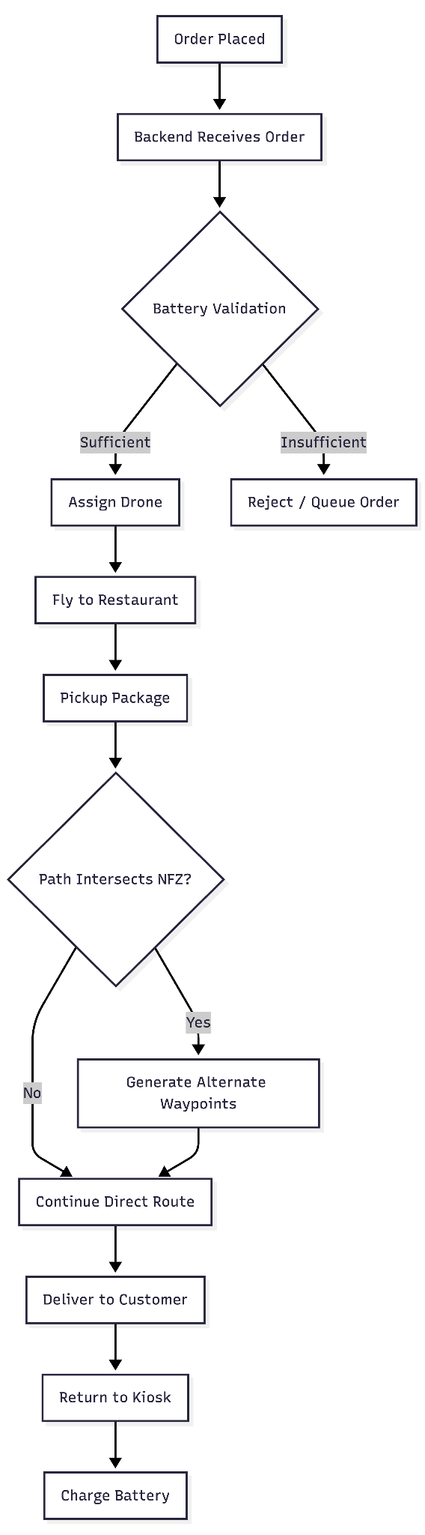

Figure 5.2 – Order Processing Flowchart

Drone State Management
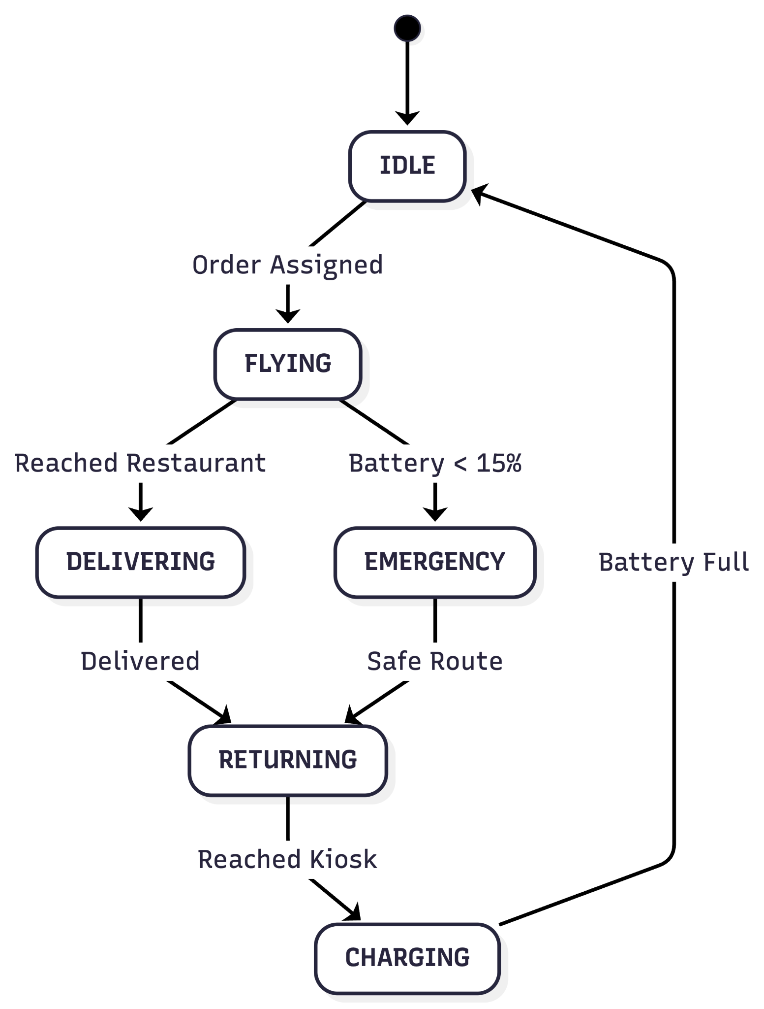

Figure 5.3 – Drone State Diagram

Battery Drain Calculation Model

Battery consumption is calculated before flight to prevent mid-air failures.

Formula Considerations

Battery Drain = Base Rate × Distance × Weather Multiplier

- Payload Factor
- Altitude Factor

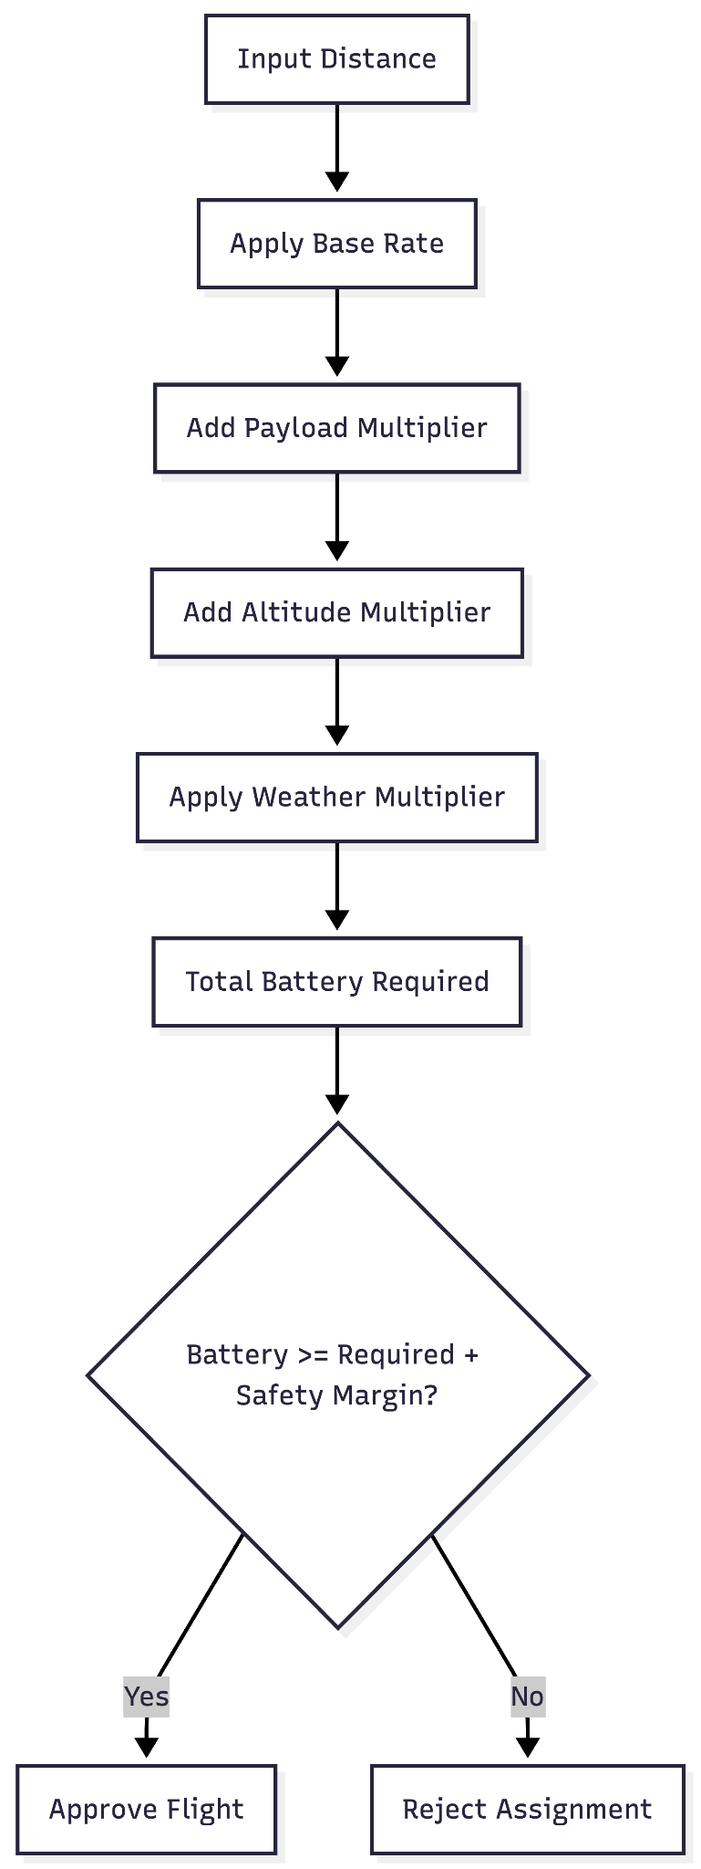

Figure 5.4 – Battery Calculation Flow

No-Fly Zone Avoidance Strategy

The system uses polygon-based detection to prevent drones from entering restricted areas.
NFZ Handling Steps

- Check if direct path intersects restricted polygon
- If intersection occurs, generate perpendicular offset waypoint
- Recalculate path
- Validate battery for new route

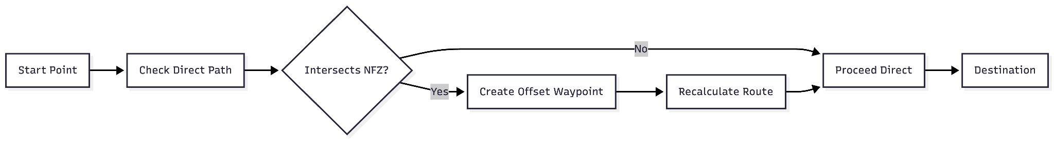

Figure 5.5 – NFZ Avoidance Concept

Real-Time Communication Design

The system uses WebSocket for continuous updates.

- Simulation tick: 100 ms
- Drone coordinates broadcast instantly
- Multi-client synchronization supported

This ensures live map tracking without manual refresh.

Advantages of Proposed System

- Integrated routing, battery, and weather modeling
- Real-time fleet visualization
- Improved delivery success rate
- Reduced risk of mid-flight failures
- Modular and scalable architecture

CHAPTER 6 IMPLEMENTATION

Introduction

This chapter explains the practical implementation of the Drone Delivery Management and Simulation Platform. It describes how the frontend, backend, simulation engine, and real-time communication components are developed and integrated. The system is designed using modern web technologies to ensure scalability, responsiveness, and modularity.

Frontend Implementation

The frontend is developed using React with TypeScript for the web dashboard and React Native for the mobile application.
Web Dashboard

The dashboard provides administrators with complete operational control. It includes modules such as:
    - Dashboard with KPI cards and simulation controls
    - Live Map with real-time drone tracking
    - Orders Management
    - Drone Fleet Management
    - Kiosk Management
    - Restaurant Management
    - Analytics Dashboard
    - Alerts Center

Component-based architecture is used to ensure reusability and maintainability. State management handles live updates received from WebSocket connections.

Backend Implementation

The backend is built using Node.js with TypeScript. It exposes REST APIs for order creation, drone management, kiosk operations, and analytics.
Responsibilities include:

    - Managing drone states
    - Processing orders
    - Executing battery validation
    - Handling No-Fly Zone logic
    - Broadcasting real-time updates

The backend also acts as the coordinator between simulation components and client applications.

Simulation Engine

The simulation engine is the core of the system. It runs on a fixed tick interval of 100 milliseconds.
Key responsibilities:

    - Updating drone positions
    - Monitoring battery levels
    - Applying weather effects
    - Detecting route intersections with No-Fly Zones
    - Triggering state transitions

Each tick recalculates drone movement and broadcasts updated data to connected clients.

WebSocket Communication

WebSocket technology is used for real-time communication.

Features:

    - Continuous broadcasting of drone coordinates
    - Synchronization across multiple clients
    - Low-latency updates
    - Event-based alert notifications

This enables live visualization without manual refresh.

Database Design

The current implementation uses an in-memory data store to manage:

    - Drones
    - Orders
    - Kiosks
    - Restaurants
    - Alerts

This approach simplifies development and testing. For production deployment, this can be replaced with a persistent database such as PostgreSQL or MongoDB.

API Design

REST APIs are designed following standard conventions. Examples:
    - /api/orders/create
    - /api/drones/list
    - /api/kiosks/status
    - /api/analytics/summary

Each API endpoint performs validation and returns structured JSON responses.

Security Considerations

Basic security measures implemented include:

    - Input validation
    - Role-based access control
    - Secure WebSocket connections
    - Error handling and logging

These mechanisms prevent unauthorized access and ensure data integrity.

CHAPTER 7 TESTING AND RESULTS

Introduction

Testing is a critical phase of system development that ensures reliability, correctness, and performance of the Drone Delivery Management and Simulation Platform. This chapter explains the testing strategy adopted and the results obtained during system validation.

Test Strategy

The system was tested using multiple approaches:

    - Unit testing for individual modules such as order processing, battery validation, and route planning.
    - Integration testing to verify communication between frontend and backend.
    - System testing to validate complete delivery workflows.
    - Performance testing to evaluate real-time updates and simulation stability.

Manual testing was used for UI verification, while backend APIs were validated using Postman.

Test Case Description

Several functional scenarios were tested to validate system behavior:

    - Creation of new delivery orders was tested to ensure successful registration and assignment.
    - Battery validation logic was verified by simulating low-battery drones and confirming assignment rejection.
    - Drone allocation was tested to confirm nearest eligible drone selection.
    - No-Fly Zone avoidance was tested by placing restricted areas on active routes and validating alternate path generation.

    - Real-time map updates were observed to confirm drone movement at 100 ms intervals.
    - Weather simulation was applied to verify changes in speed and battery consumption.
    - Emergency return was triggered when battery levels dropped below critical thresholds.
    - Charging kiosks were tested for queue management and slot availability.
    - Alert generation was verified for low battery, NFZ proximity, and weather warnings.
    - Analytics KPIs were monitored to ensure accurate updates.

All test scenarios executed successfully.

Performance Evaluation

The system was evaluated under multiple operational scenarios including normal conditions, peak load, and adverse weather.
Observations:

    - WebSocket updates provided smooth real-time visualization.
    - Intelligent battery assignment reduced mid-flight failures.
    - Multiple drones operated simultaneously without noticeable delay.
    - Map layers rendered efficiently even during high activity.

Result Analysis

Testing confirmed that:

    - Orders progressed correctly through pickup, delivery, and return stages.
    - Drones navigated safely around No-Fly Zones.
    - Weather conditions realistically affected operations.
    - Charging kiosks maintained stable drone queues.

    - Alerts were generated for critical system events.
    - Analytics accurately reflected fleet performance.

The system achieved reliable delivery simulation with minimal errors.

Screenshots

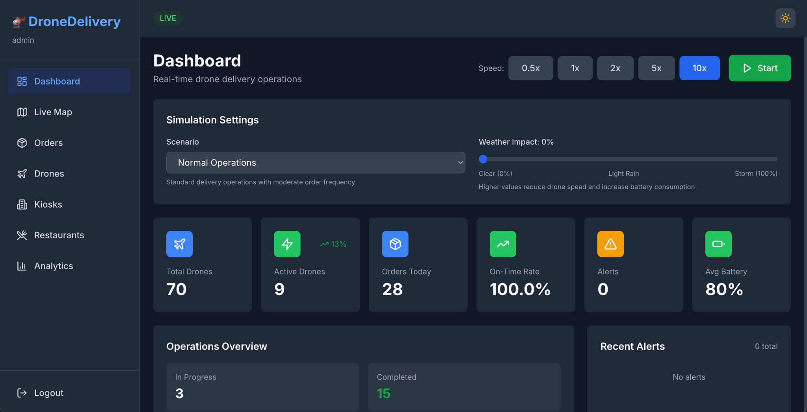

Figure 7.6.1 : Dashboard

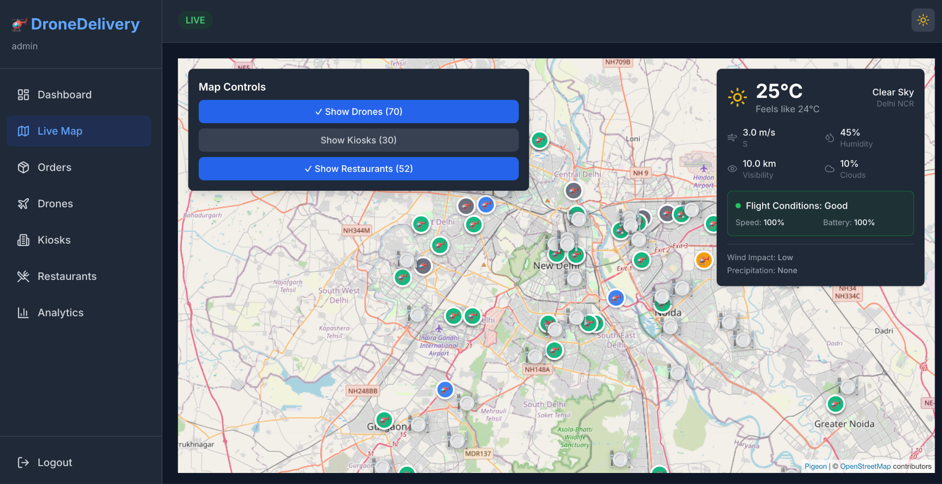
Figure 7.6.2 : Live Map
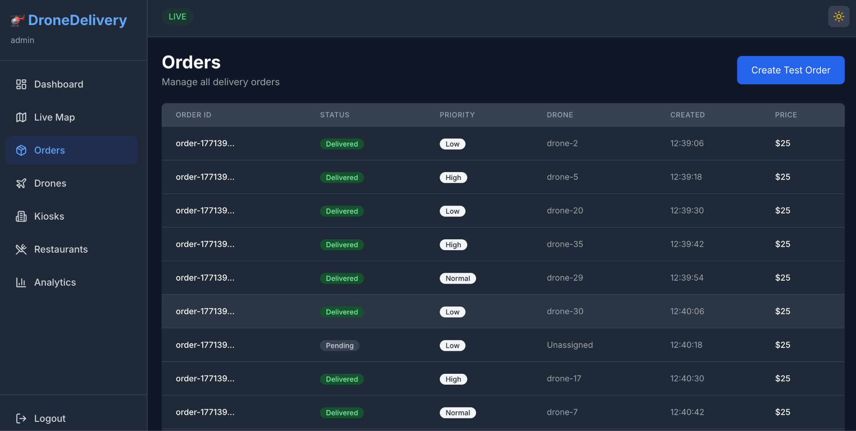
Figure 7.6.3 : Orders

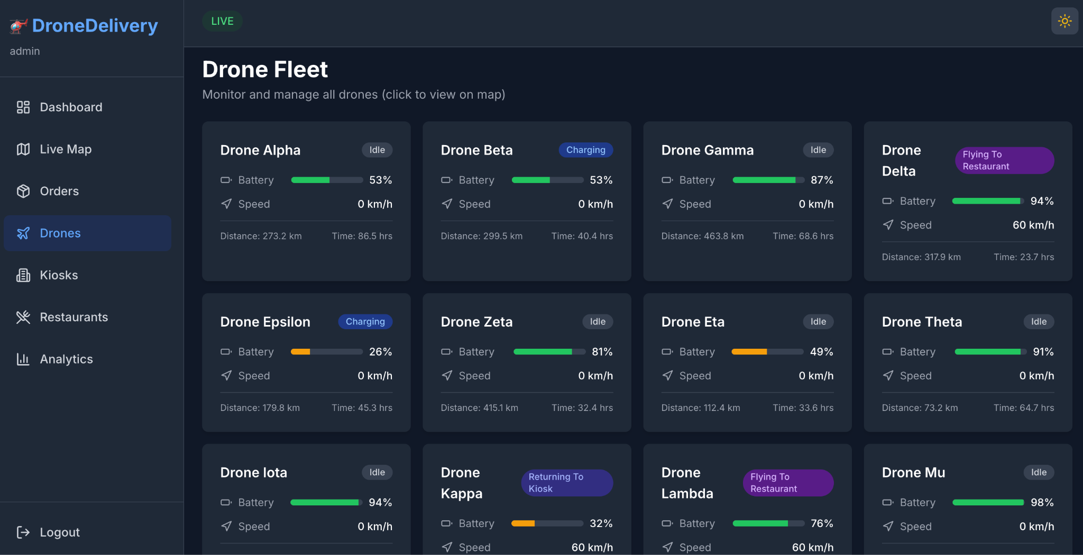
Figure 7.6.4 : Drone Fleet Management
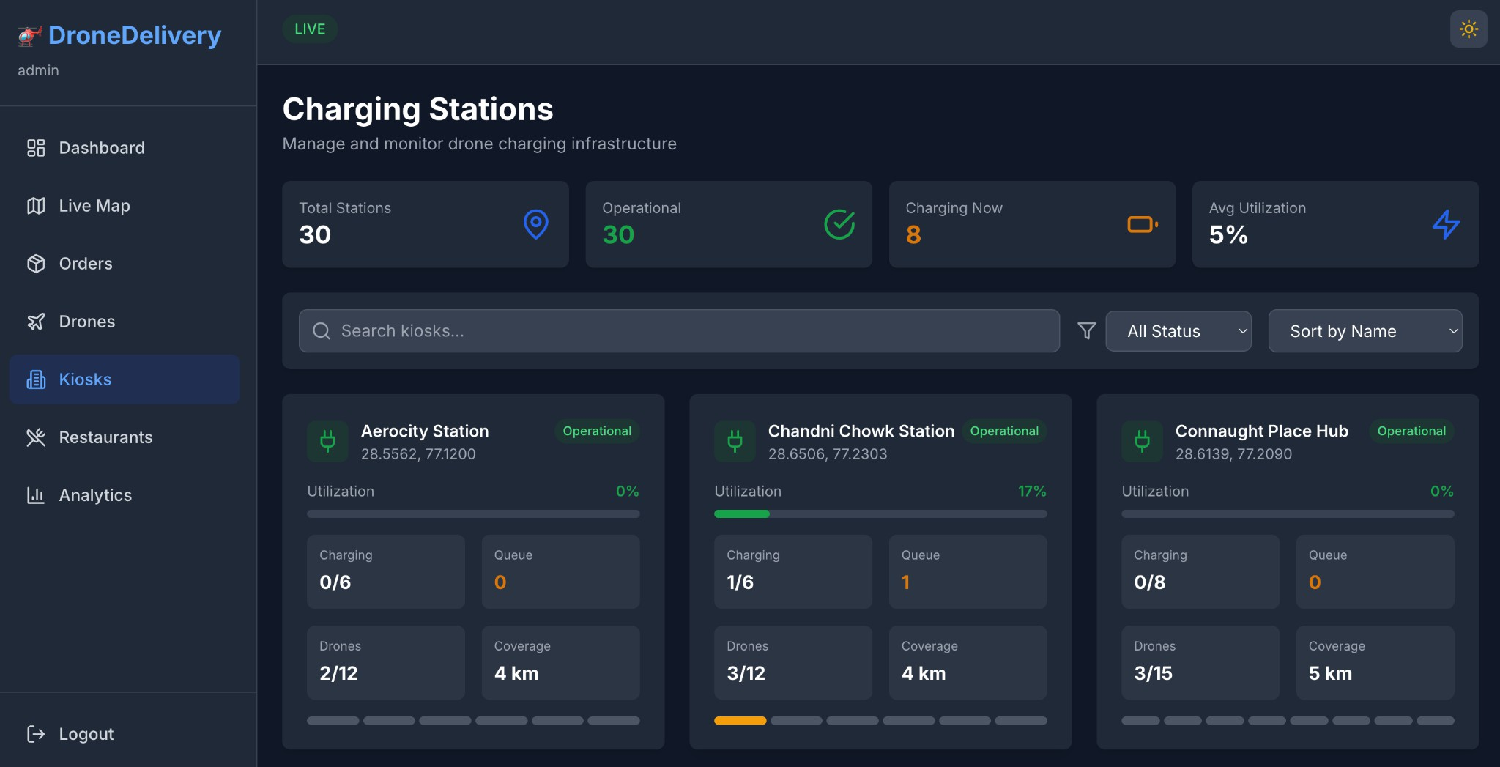
Figure 7.6.5 : Kiosk Management

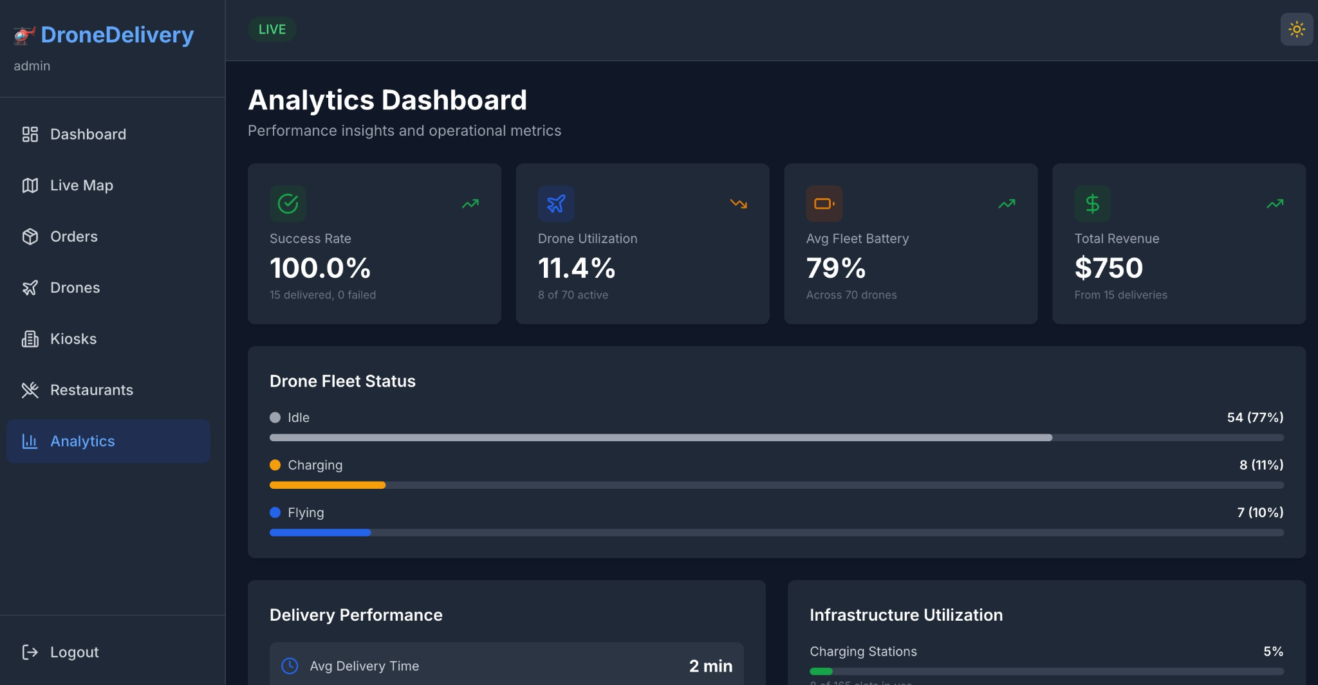
Figure 7.6.6 : Analytics

CHAPTER 8 CONCLUSION AND FUTURE WORK

Conclusion

The Drone Delivery Management and Simulation Platform successfully demonstrates how autonomous drone systems can be managed efficiently through intelligent software architecture. The system integrates real-time tracking, battery-aware decision making, No-Fly Zone avoidance, weather simulation, and centralized analytics into a unified environment.
Throughout development, emphasis was placed on safety, scalability, and modular design. The implementation achieved stable real-time communication using WebSocket technology, smooth visualization of drone movement, and accurate simulation of operational constraints such as battery drain and restricted airspaces.
Testing confirmed that the platform reliably handles order processing, drone assignment, route planning, charging management, and alert generation. The analytics dashboard provides meaningful performance insights such as delivery success rate, fleet utilization, and infrastructure efficiency.
Overall, the project meets its objectives by offering a realistic and extensible drone delivery simulation system suitable for academic research, experimentation, and prototype development.

Achievements

The key achievements of this project include:

    - Development of a full-stack drone delivery simulation platform.
    - Implementation of battery-aware pre-flight validation.
    - Integration of No-Fly Zone detection and dynamic rerouting.
    - Real-time drone tracking with 100 millisecond updates.

    - Weather-influenced operational modeling.
    - Charging kiosk and infrastructure management.
    - Analytics dashboard for operational monitoring.
    - Modular architecture supporting future scalability.

Limitations

Despite successful implementation, the system has certain limitations:

    - The platform operates in a simulated environment without physical drone integration.
    - Data is currently stored in memory rather than a persistent database.
    - Simplified flight physics compared to real-world UAV systems.
    - Limited geographical scope restricted to a defined simulation area.
    - No customer-facing mobile ordering interface.

These limitations provide opportunities for further enhancement.

Future Enhancements

The following improvements can be incorporated in future versions:

    - Integration with physical drone hardware and real flight controllers.
    - Implementation of a persistent database such as PostgreSQL or MongoDB.
    - AI-based dynamic route optimization using machine learning.
    - Real-time wind vector modeling for advanced weather simulation.
    - Collision detection using advanced spatial algorithms.
    - Customer-facing mobile ordering application.
    - Cloud deployment with scalable infrastructure.
    - Integration with digital payment gateways.
    - Advanced predictive maintenance analytics.

With these enhancements, the platform can evolve from a simulation system into a

deployable real-world drone delivery management solution.

A1.1 Simulation engine

APPENDICES

Appendix I Source Code

// Runs every 100ms - core simulation tick

this.intervalId = setInterval(() => { this.update(); }, 100);

// Each tick: update drones, check safety, assign orders, broadcast private update() {
const speed = dataStore.simulationState.speed; this.droneControllers.forEach(controller => controller.update(deltaTime, speed)); this.checkDroneCollisions();
this.checkLowBatteryAlerts(); this.assignOrders();
this.onUpdate({ drones, orders, kpi }); // broadcast via WebSocket

}

// Weather impact setter setWeatherImpact(impact: number) {
dataStore.simulationState.weatherImpact = Math.max(0, Math.min(100, impact));

}

A1.2 Order Assignment

// Sort orders by priority, find nearest available drone const pendingOrders = dataStore.getAllOrders()
.filter(o => o.status === OrderStatus.PENDING)

.sort((a, b) => ({ URGENT:0, HIGH:1, NORMAL:2, LOW:3 })[a.priority]

- ({ URGENT:0, HIGH:1, NORMAL:2, LOW:3 })[b.priority]);

// Find closest drone to restaurant

for (const drone of availableDrones) {

const distance = calculateDistance(drone.position, restaurant.position);

if (distance < minDistance) { minDistance = distance; closestDrone = drone; }

}

controller.assignOrder(order); // assign to closest

A1.3 Pre-flight Battery Validation

// Calculate total battery needed for full mission

const d1 = calculateDistance(drone.position, restaurant.position);

const d2 = calculateDistance(restaurant.position, order.deliveryAddress); const d3 = calculateDistance(order.deliveryAddress, kiosk.position);

const totalDrain = calculateBatteryDrain(drone, d1, weather, weatherImpact)

+ calculateBatteryDrain(drone, d2, weather, weatherImpact)

+ calculateBatteryDrain(drone, d3, weather, weatherImpact);

const requiredBattery = totalDrain * 1.5; // 50% safety margin

if (drone.battery < requiredBattery) return false; // REJECT

if (drone.battery < 60) return false; // REJECT - too low

A1.4 Emergency Return

// Trigger emergency return when battery critically low

if (this.drone.battery < 10) this.initiateEmergencyReturn();

private initiateEmergencyReturn() { if (this.drone.currentOrderId) {
order.status = OrderStatus.FAILED; // cancel current order this.drone.currentOrderId = null;
}

this.drone.status = DroneStatus.RETURNING_TO_KIOSK;
// Route back to kiosk avoiding NFZ this.drone.route = calculateOptimizedRoute(

this.drone.position, kiosk.position, noFlyZones

);

}

A1.5 Charging Logic

// Start charging when battery < 40%

if (this.drone.battery < 40) this.requestCharging();

// Charge at rate of 50% per hour

this.drone.battery = Math.min(100, this.drone.battery + 0.01389 * deltaTime);

// Stop charging at 98% (full health) if (this.drone.battery >= 98) {
this.drone.status = DroneStatus.IDLE; this.drone.isAvailable = true; kiosk.availableChargingSlots++;
}

A1.6 No-Fly Zone Avoidance
// Sample 20 points along path to detect NFZ intersection function doesPathIntersectNoFlyZone(start, end, zones) {

for (let f = 0; f <= 1; f += 0.05) {

const point = interpolatePosition(start, end, f);

if (checkNoFlyZoneViolation(point, zones)) return zone;

}

return null;

}

// Build route with avoidance waypoints (max 5)

export function calculateOptimizedRoute(start, end, noFlyZones) { const route = [start];
while (waypointsAdded < 5) {

const violation = doesPathIntersectNoFlyZone(currentStart, end, noFlyZones); if (!violation) break;
const waypoint = calculateAvoidanceWaypoint(currentStart, end, violation); route.push(waypoint); // add detour point
currentStart = waypoint; waypointsAdded++;
}
route.push(end); return route;

}

A1.7 Battery Drain Formula

// K-value constants

const BASE_DRAIN_FACTORS = {

baseConsumption: 1.0, // k1: 1% per km payloadFactor: 0.3, // k2: 0.3% per kg per km altitudeFactor: 0.2, // k3: 0.2% per 100m per km
};

// Weather multipliers

function getWeatherMultiplier(weather) {

return { CLEAR:1.0, LIGHT_RAIN:1.2, HEAVY_RAIN:1.5, STRONG_WIND:1.4,
STORM:2.0 }[weather];

}

// Total drain calculation

let drain = baseConsumption * distance;

drain += payloadFactor * drone.currentPayload * distance;

drain += altitudeFactor * (drone.position.altitude / 100) * distance; drain *= getWeatherMultiplier(weather); // apply weather multiplier

A1.8 Collision Avoidance - Altitude Adjustment

const MIN_SEPARATION = 0.1; // 100 metres

// Check all flying drone pairs

if (calculateDistance(drones[i].position, drones[j].position) < MIN_SEPARATION) {

// If at same altitude, one drone climbs 20m

if (Math.abs(drone1.altitude - drone2.altitude) < 10) {

const climbingDrone = drone1.id < drone2.id ? drone1 : drone2; climbingDrone.position.altitude += 20;
}

}

A1.9 Weather Speed Reduction

// Up to 50% speed reduction at 100% weather impact const weatherMultiplier = 1 - (weatherImpact / 100) * 0.5;
this.drone.speed = this.drone.maxSpeed * weatherMultiplier;

A1.10 Altitude Layering for Flight Direction

// N/S flights at 80m, E/W flights at 100m to reduce collision risk export function calculateFlightAltitude(start, end): number {
const bearing = calculateBearing(start, end);

return (bearing >= 315 || bearing < 45) || (bearing >= 135 && bearing < 225)

? 80 // North/South

: 100; // East/West

}

Appendix II Screenshots
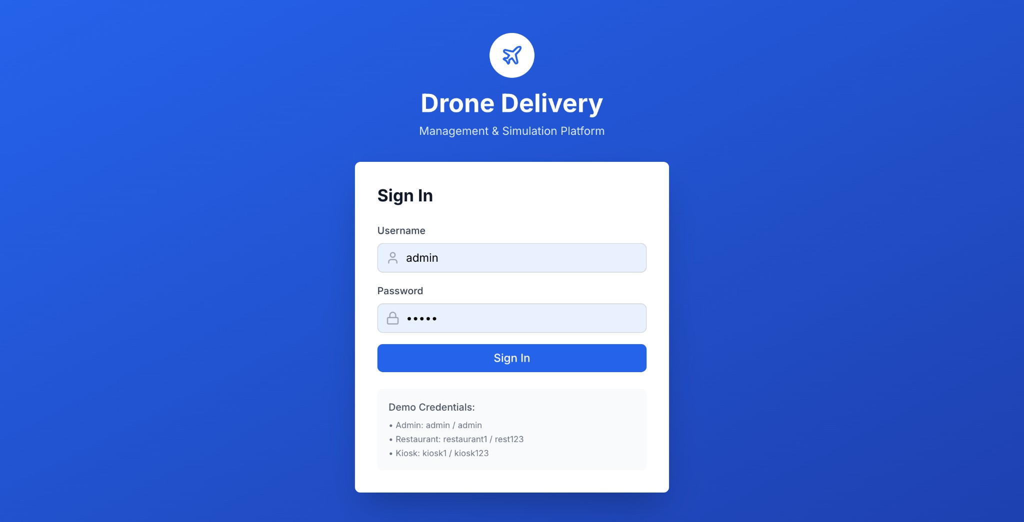
Figure A2.1 : Login Page
Figure A2.1: Login Page
The login page presents a clean authentication form with username and password fields. Users enter credentials (admin/admin) to access the platform. The page includes the project branding and a secure session management system.



Figure A2.2 : Dashboard
Figure A2.2 : Dashboard
The main dashboard displays six real-time KPI cards showing total drones, active drones, pending orders, delivery success rate, average battery level, and total revenue. Below the KPIs are simulation controls (Start/Pause/Resume), a speed multiplier selector (1x–10x), a scenario selector (Normal/Peak Hour/Bad Weather), and a weather impact slider (0– 100%). A recent alerts panel is shown on the right.

Figure A2.3 : Live map

Figure A2.3 : Live Map
The live map renders an interactive MapLibre GL map of Delhi NCR with a 45° 3D tilt. Color-coded drone markers (blue = flying, grey = idle, yellow = charging) move in real time. Kiosk markers (green) and restaurant markers (orange) are visible with clickable popups. Layer toggle buttons on the left allow showing/hiding each entity type independently.


Figure A2.4 : Orders page
Figure A2.4 : Orders Page

The orders page lists all active, pending, completed, and failed orders with status badges. Each row shows order ID, restaurant name, assigned drone, priority level, and estimated delivery time. A "Create Order" button opens a form to place new orders.
Figure A2.5 : Drone Fleet Page
Figure A2.5 : Drone Fleet Page
The drones page shows a table of all 20 drones with real-time data: battery level (shown as a coloured progress bar), current status, assigned kiosk, total distance flown, and flight time. Action buttons allow force-returning or emergency-landing individual drones.


Figure A2.6 : Kiosk Management
Figure A2.6 : Kiosk Management Page The kiosk management page displays charging station cards with a search bar, status filter (All/Operational/Offline), and sort options. Each card shows kiosk name, utilization percentage with a progress bar (green < 50%, yellow 50–80%, red > 80%), charging slots in use, queue length, and drone count. Clicking a card opens a detail modal.

Figure A2.7 : Analytics Dashboard
Figure A2.7 : Analytics Dashboard
The analytics dashboard shows four KPI cards (Delivery Success Rate, Drone Utilization, Average Fleet Battery, Total Revenue) with colour-coded health indicators and trend

arrows. Below are a Fleet Status Distribution panel (progress bars for Idle/Charging/ Flying drones) and an Infrastructure Utilization panel (charging stations, restaurant network, fleet efficiency percentages).



SUSTAINABLE DEVELOPMENT GOALS
The Sustainable Development Goals are a collection of 17 global goals designed to blueprint to achieve a better and more sustainable future for all. The SDGs, set in 2015 by the United Nations General Assembly and intended to be achieved by the year 2030, In 2015, 195 nations agreed as a blueprint that they can change the world for the better. The project is based on one of the 17 goals.

Questions | Answer Samples
Which SDGs does the project directly address? | SDG 9 – Industry, Innovation and Infrastructure  SDG 11 – Sustainable Cities and Communities
 | SDG 13 – Climate Action
 | The project uses drone-based delivery
W h a t s t r a t e g i e s o r | simulation, intelligent route planning, and
a c t i o n s a r e b e i n g | real-time fleet monitoring to improve
implemented to achieve | logistics efficiency and support sustainable
these goals? | transportation.
 | Progress is measured using system metrics
How is progress | such as delivery success rate, drone
measured and reported in | utilization, and battery efficiency displayed
relation to the SDGs? | on the analytics dashboard.
How were these goals identified as relevant to the project’s objectives? | These SDGs align with the project’s goal of d e v e l o p i n g i n n o v a t i v e l o g i s t i c s infrastructure, improving urban delivery systems, and promoting environmentally sustainable transportation.
 | The project is a simulation-based system,
A r e t h e r e a n y | but future collaboration with drone
p a r t n e r s h i p s o r | technology companies and smart city
collaborations in place to | initiatives can enhance its real-world impact.
enhance this impact?

REFERENCES

- M. Chen, L. Wang, and K. Zhang, “Simulation and management of autonomous drone fleets for last-mile delivery,” IEEE Internet of Things Journal, 2024.
- L. Garcia, M. Rossi, and Y. Chen, “Urban drone delivery systems: A comprehensive review of regulations, technologies, and applications,” IEEE Communications Surveys & Tutorials, 2024.
- A. Johnson, P. Miller, and R. Brown, “Battery-aware task assignment in multi-drone delivery networks,” IEEE Transactions on Vehicular Technology, 2024.
- A. Kumar, R. Singh, and P. Sharma, “Drone-based delivery systems: A survey on route planning,” IEEE Xplore, 2023. (Base Paper)
- S. Lee and J. Park, “Energy-efficient route planning for urban drone delivery networks,” IEEE Transactions on Intelligent Transportation Systems, 2024.
- J. Liu, X. Zhou, and F. Li, “Digital twin–based simulation of drone delivery networks for smart logistics,” IEEE Access, 2025.
- T. Nguyen and H. Kim, “Real-time drone fleet monitoring and visualization using web-based dashboards,” IEEE Access, 2025.
- R. Patel and S. Verma, “Geofencing and no-fly zone aware path planning for UAV delivery systems,” IEEE Aerospace and Electronic Systems Magazine, 2024.
- K. Rao and N. Mehta, “Weather-aware UAV routing and scheduling for smart city logistics,” IEEE Smart Cities Journal, 2024.
- D. Wilson and S. Ahmed, “Simulation framework for large-scale autonomous drone delivery operations,” IEEE Systems Journal, 2025.

